2026 Synod Assembly Registration Checklist

- Copy and distribute all enclosed pages to Voting Members upon receipt.

- Register for the Assembly at https://bit.ly/2026nemnsa
The deadline is April 3, 2026.

- All Voting Members must register online at the URL address above. This year there is online group registration which means that a congregation’s voting members can register at the same time with one check/payment.

- Early Bird Registration: $165.00 on or before March 15. Late Registration after March 15 is $170.

- Lodging and Meals: please follow the instructions for registering with Breezy Point for lodging and meals. There is a paper form for lodging/meals and another form for commuters. Roommates should send their registration forms together.

- Download, copy and distribute the Bulletin of Reports to all Voting Members from your congregation. The Bulletin of Reports will be available at the Synod Assembly website around April 13.

- Check-In information will be provided to Voting Members prior to the Assembly.
- Please see the enclosed information:
  - Emmaus Fund launch
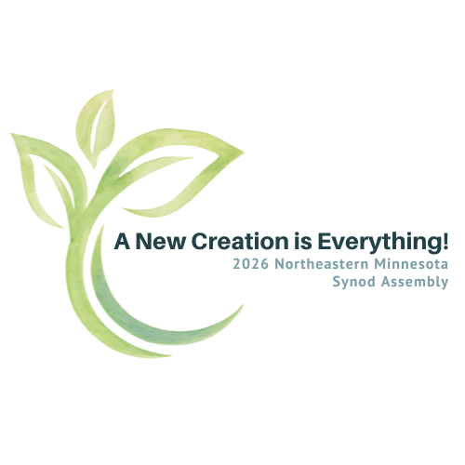
  - Quilt Auction and MarketPlace
  - Resolution information
  - Nomination information
  - Congregational Information form

Questions: Contact Assembly Register Anne Laechel at 218.851.2214 or anne.laechel@gmail.com.

